The Chiltern Way Challenge Instructions

Please find below all the information you will need to make your race weekend run as smooth as possible.

Start: Finish: Princes Risborough School, HP27 0DR

Locations
 |  | Day 1 what3words
Start | Post code | HP27 0DR ///outboard.closet.weekend
 | Grid Ref | SP 810029
CP 1 | Post code | HP22 6QJ ///gong.lace.tiredness
 | Grid Ref | SP 862052
CP 2 | Post code | HP23 6LU ///mixing.leaflet.interview
 | Grid Ref | SP 914091
CP 3 | Post code | HP5 2UU ///else.typed.index
 | Grid Ref | SP 929053
CP 4 | Post code | HP16 9PW ///spliced.brother.branching
 | Grid Ref | SP 869036
Finish | Post code | HP27 0DR ///outboard.closet.weekend
 | Grid Ref | SP 810029

Timings

Starts

There will be no mass starts at this event, instead we will operate a ‘rolling start’ for walkers from 0800 to 0830, medium paced runners from 0830 to 0930, with only fast runners going off as a group after 0930.
As per COVID separation arrive race ready, stay in your car or away from the start line until called and make sure you are carrying hand sanitiser and a mask or face covering.

Registration

Our support desk will be open from about 0700. All competitors must collect their timing chip on arrival quoting their bib number. If you didn’t get a number in the post, ask at registration and you will be given your race number.
A map of the route is available near the start.

Transportation:

Getting to and from the Start/Finish

By Rail – Chiltern Railways
Trains to Princes Risborough leave from London Marylebone about every half hour with a duration of between 30 and 58 minutes. Trains from Birmingham leave about every 30 minutes and take about 1h 30 min.
Mini-bus shuttle to and from Princes Risborough station – you will be rrquired to wear a mask is using the shuttle

By Road
Princes Risborough is about a 20 minute drive on the A4010 from Junction 4 of the M40 (High Wycombe) or 20 minutes on the B4009 from Junction 6 of the M40 .
Free parking all day.

Kit Required
- The list below is a list of recommended, not compulsory, equipment to be taken.
- Compulsory kit:
  - a mobile phone with full battery and switched on to ring not silent.
  - Water bottle or bladder with a minimum of 500ml
- If weather dictates the Race Director may make some other equipment also compulsory.

Recommended Kit
- Running shoes or walking boots
- Running/ walking clothing – shorts, T shirt etc – you may want to wear long leggings, and long sleeves for overgrown sections of the route.
- Waterproof jacket (if rain forecasted)
- Race vest or rucksack

- Don’t forget your sun cream!

Route Information

- The route is well marked, but you need to keep an eye on your map.
- You can view the route on our website by following the link from the event page.
- You will be given a map to help with your progress.
- You can request GPS data from brian@xnrg.co.uk to load directly onto your GPS watch.

Route Management.

The Chiltern Challenge has 4 checkpoints, approximately 10 Km apart. These checkpoints (or aid stations) are for health checks, water and food replenishment. To keep everyone as safe as possible we are controlling runners access to checkpoints, so please bear with us if it isn’t as quick as you’re used to!

Our medical teams are also part of the checkpoint staff.

We also have a dedicated Course Manager, who coordinates all activities and checkpoints along the route.

Spectators

There are various places en-route for spectators to cheer on their family and friends. The Check Point locations are not ideal for meeting competitors.
CP1 is fine with some parking for 2 or 3 cars.
CP2 there is plenty of parking
CP3 we cannot have any spectators at this location
CP4 there is very limited parking so not ideal.

We would recommend that spectators support as the competitors go through Wendover and Great Missenden. The Black Horse in Great Missenden is a good spot, because the competitors run right through it.

Checkpoints

Start 10.1 Km CP1 9.5 Km CP2 9.6 Km CP3 10.8 Km CP4 8.4 Km Finish
└─────────┴──────────┴──────────┴─────────┴───────────┘

Checkpoint Food
Water, squash and coke if you’re lucky. Small pre-packed snacks.

Bring your own cup – no cup no drink!

Detailed information on distances, timing, ascent and descent, is below
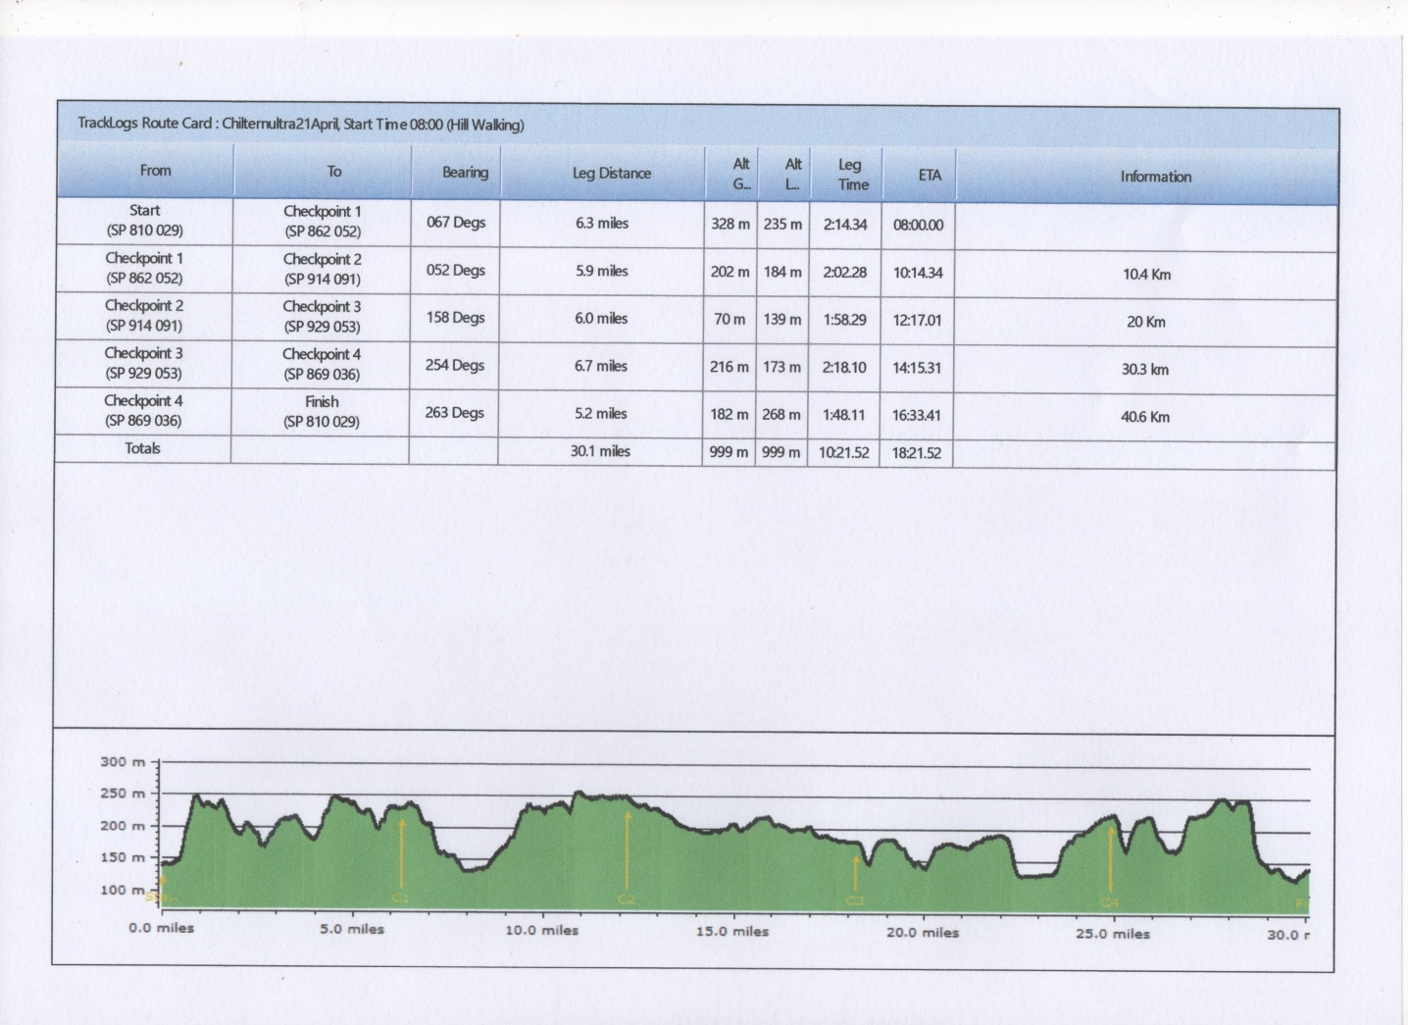

Safety on the Course

The following information is important. Please read it carefully. This information will also be covered in the compulsory briefing prior to the event.

Route Hazards

- The ground maybe slippery so please be careful.
- Be aware and take caution crossing all roads – some are busy. Non are marshalled
- Be aware of other path users especially where it is narrow, dogs off the lead, horses, mountain bikes, walkers are all potential hazards. Some people are nervous about runners, so please give people a wide berth where possible.
- Caution with roots, rocks, steps, stiles that may be hidden or slippery
- All gates MUST be closed after you.

Medical

- Our paramedics will be on hand all weekend to assist with serious or minor injuries.
- Any incidents will be dealt with as part of our medical emergency procedures.
- It is important that you check the medical page of the website to ensure you have understood the potential medical risks of running these extreme distances.
- It is also important that you let the organisers know in advance of any medical problems that you know about and may be relevant to the race.

Actions On

Injury

- Try to get to a Checkpoint, where we will be able to recover you or treat you.
- Get to a recognisable location where you can report your position and call the race director to be recovered. (number on the map)
- Most emergency services use ‘what3words’. Download the app onto your phone.
- Tell another competitor where you are and ask them to inform the next CP, we will then plan your recovery

Our paramedic team will be on the course and at the finish and will manage all situations that need treatment. XNRG Medic – 07599937708

Serious Emergency (i.e. someone is knocked down) ring 999 first, then ring the XNRG Medic – 07599937708

Medical Emergencies will be taken to A & E

Lost

- Keep eyes on signs.
- Use the map.
- Look for fellow competitors behind or in front.
- Retrace steps to last known location.
- If still lost, try to get to a road or town, ask at a pub or shop to help locate on the map.
- Or find a road with a name, a town and ring the race director, (number on the map), to help guide you in.
- Using what3words (download the app) will make it easier for us to locate you.

Withdrawal

Only withdraw at a checkpoint and ensure the CP staff have been told you are withdrawing. We will get you to the finish when the CP closes.

Missing Checkpoint Time

- Checkpoint open and close times are on the route card.
- If you are too fast, or start in the wrong start and the CP is not set up, then you will need to wait.
- If you are too late for a CP, we will keep it open till you arrive; if you are late for 2 CPs we may ask you to withdraw for the day and save your energy for the next day.

