The Druid’s Challenge Instructions 7th and 8th of November 2020

We are looking forward to seeing you at the Druid’s, albeit with a different format – but with XNRG’s inimitable atmosphere. Please find below all the information you will need to make your race weekend run as smoothly as possible.

The change in event format means some details are still being finalised and this page will be updated in due course.

The event will be ‘out and back’ on both days on the scenic yet challenging Ridgeway National Trail, using Princes Risborough School as a base. There is no overnight accommodation on site.

Please check our Coronavirus (Covid 19) policy before you come.

Registration: Princes Risborough School, Merton Road, Princes Risborough HP27 0DR (SP 809029) open from 0700
Saturday Start and Finish : Princes Risborough School HP27 0DR (SP 809029)
Sunday Start and Finish: Princes Risborough School HP27 0DR (SP 809029)

Locations
 |  | Day 1 | Day 2
Start & Finish | Post code | HP270DR | HP27 0DR
 | Grid Ref | SP809029 | SP809029
CP 1 | Post code | Awaits | Awaits
 | Grid Ref
CP 2 | Post code | Awaits | Awaits
 | Grid Ref
CP 3 | Post code | Awaits | Awaits
 | Grid Ref

Timings

Please note your Day 1 start times will be determined by the information you provide in your entry form. If you are doing both days, your start time on day 2 will be determined by your finish the previous day.

Registration
Race numbers will be posted out pre event. When you arrive we will give a you a route card and a you can collect your timing chip. The cafe will be open, serving hot drinks.
If you travel by car please leave any kit in it. If you have come by train, or have been dropped off, we can look after a kitbag for you.

Getting to the event

Free parking is available at the school

We will operate a minibus shuttle to and from Princes Risborough Train Station before and after the event.

Please note there is no accommodation on site and we cannot provide a shuttle service to hotels (due to limitations on numbers of passengers we can carry).

Route Information

- Both days routes are out to a turn point then back on the reverse route to the start.
- GPX files are available for the out and back routes. There are links to the GPX files at the bottom of this document. OR
- You can request the GPX files from brian@xnrg.co.uk to load directly onto your GPS watch.
- We will be following the Ridgeway, a well marked National Trail,
- You can view the route on our website by following the link from the event page.

Day 1
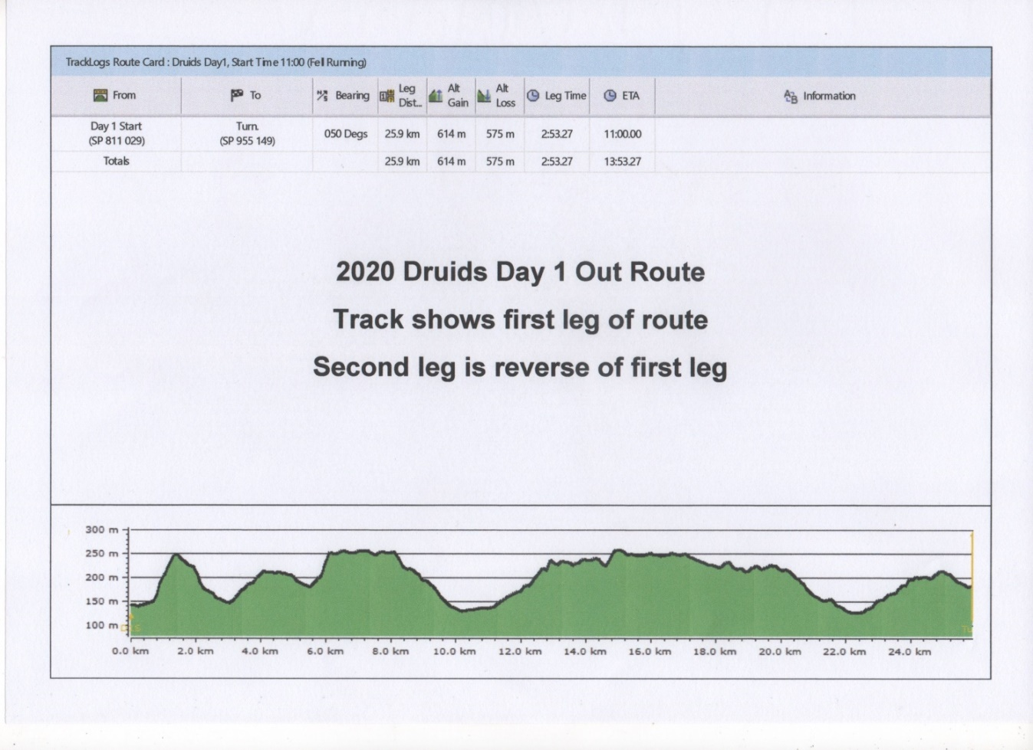
Day 2

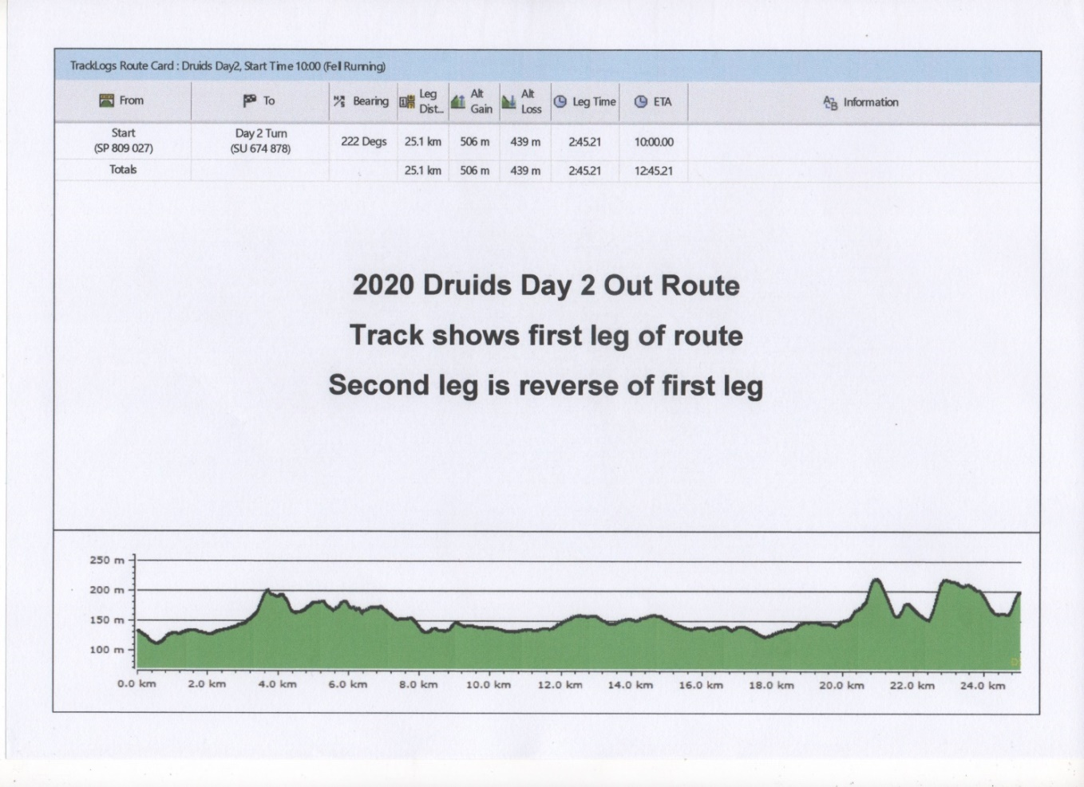

Checkpoints
Day 1 Start 11miles CP1 5.7miles CP2 6.1miles CP3 6.4miles Finish
└───────────┴──────────┴──────────┴────────────┘

Day 2 Start 7.5miles CP1 6.9miles CP2 8.4miles CP3 3.8miles Finish
└───────────┴──────────┴──────────┴───────────┘

Checkpoint Food
Water, squash and on occasions - coke. Small snacks, both sweet and savoury.

Safety on the Course
The following information is important. Please read it carefully. This information will also be covered in the compulsory briefing prior to the event.

Kit Required
- The list below is a list of recommended, not compulsory, equipment to be taken. The only compulsory kit is a mobile phone with full battery and switched on to ring not silent.
- If weather dictates the Race Director may make some other equipment also compulsory.
- For your overnight kit please bring what you need to be comfortable and at minimum the kit on the list below in a reasonable size overnight bag and we’ll transport if for you.

Kit List

Running.
Running shoes or walking boots Running gear
Thermal top Warm hat Whistle Rucksack

Water bottles or bladder Emergency silver blanket Mobile phone fully charged Head torch and spare batteries (absolutely vital)
Long trousers / leggings
Hand sanitiser and face covering

Route Hazards

- The ground maybe slippery so please be careful, we advise wearing trail shoes.
- Be aware and take caution crossing all roads – some are busy. Non are marshalled
- Be aware of other path users especially where it is narrow, dogs off the lead, horses, mountain bikes, walkers are all potential hazards.
- Caution with roots, rocks, steps, stiles that may be hidden or slippery

Medical
- Our paramedics will be on hand all weekend to assist with serious or minor injuries.
- Any incidents will be dealt with as part of our medical emergency procedures.
- It is important that you check the medical page of the website to ensure you have understood the potential medical risks of running these extreme distances.
- It is also important that you let the organisers know in advance of any medical problems that you know about and may be relevant to the race.

Actions On
Injury

- Try to get to a Checkpoint, where we will be able to recover you or treat you.
- Get to a recognisable location where you can report your position and call the race director to be recovered. (number on the route card)
- Tell another competitor where you are and ask them to inform the next CP, we will then plan your recovery

Our paramedic team will be on the course and at the finish and will manage all situations that need treatment. XNRG Medic – 07599 937708
Serious Emergency (i.e. someone is knocked down) ring 999 first, then ring the XNRG Medic
Medical Emergencies will be taken to A & E

Lost
  - Keep eyes on the National Trail signs.
  - Use the route card and map.
  - Look for fellow competitors behind or in front.
  - Retrace steps to last known location.
  - Ask a local walker/runner for help.
  - If still lost, try to get to a road or town, ask at a pub or shop to help locate on the map.
  - Or find a road with a name, a town and ring the race director, (number on the route card), to help guide you in.

Withdrawal
Only withdraw at a checkpoint and ensure the CP staff have been told you are withdrawing. We will get you to the finish when the CP closes.

Missing Checkpoint Time
  - Checkpoint open and close times are on the route card.
  - If you are too fast, or start in the wrong start and the CP is not set up, then you will need to decide whether you keep going or wait.
  - If you are too late for a CP, we will keep it open till you arrive; if you are late for 2 CPs we may ask you to withdraw for the day and save your energy for the next day.

Dark

Head torches must be worn once it is dark, anyone arriving at a CP in the dark without a head torch will be pulled out.

