The Humanity Direct 50km Ultra Challenge Instructions

Please find below all the information you will need to make your race weekend run as smooth as possible.

Start: Finish: Tring Cricket Club, Beechwood, London Rd, Tring, Hertfordshire HP23 5NG (Entrance in Station Road).

Locations
 |  | Day 1
Start | Post code | HP23 6HA
 | Grid Ref | SP 931116
CP 1 | Post code | HP22 5NL
 | Grid Ref | SP 884100
CP 2 | Post code | HP23 5QU
 | Grid Ref | SP 948118
CP 3 | Post code | HP4 1LT
 | Grid Ref | SP 977117
CP 4 | Post code | HP23 5RZ
 | Grid Ref | SP 955148
Finish | Post code | HP23 6HA
 | Grid Ref | SP 931116

Timings
07:00 | Minibus pick up starts from Tring Station
07:00 | Registration open
07:30 | Walkers briefing
08:00 | Walkers Start
08:30 | Runners race briefing
09:00 | Runners Start
09:30 | Elite runners briefing (target time below 6 hours)
10:00 | Elite runners start
14:00 | Massage and refreshments available
16:00 | Prize giving or when enough winners have finished
 | Minibus to the station running all afternoon

Registration

All competitors must register on arrival. At registration you will be given your race number and map.

Getting to and from the Start
Transportation:

By Rail – London Midland Railways
Trains to Tring leave from London Euston about every 10 to 20 minutes with a duration of between 34 and 48 minutes. Trains from Birmingham leave about 3 per hour and take about 1h 30 min.
Mini-bus shuttle to and from Tring station.

By Road
Tring is about a 15 minute drive on the A41 from Junction 20 of the M25 or 1hr10 minutes on the A41 from Junction 19 of the M40 . Post code HP23 5NG
Free parking all day. NOTE: Parking entrance is in Station Road. HP23 5NG

Kit Required

- The list below is a list of recommended, not compulsory, equipment to be taken. The only compulsory kit is a mobile phone with full battery and switched on to ring not silent.
- If weather dictates the Race Director may make some other equipment also compulsory.

Kit List

Compulsory kit:

Running shoes or walking boots
Running clothing as required
Minimum of 500ml water in a bottle or bladder
Mobile phone switched on, fully charged and not on silent

Optional depending on weather or as instructed:
Waterproof jacket
Thermal top
Warm hat
Whistle
Rucksack / ultra vest

Route Information

- The route is well marked with tape and arrows, but you need to keep an eye on the map.
- You can view the route on our website by following the link from the event page.
- You will be given a map to help with your progress.
- You can download a GPS trace from the event page website

Route Management.

The Humanity Direct has 4 checkpoints, approximately 10 Km apart. These checkpoints (or aid stations) are for health checks, water and food replenishment. Unfortunately there is very little room to allow friends and family an opportunity to see competitors (see the spectators section of this document for our recommendations). Our medical teams are also part of the checkpoint staff.

We have a dedicated Course Manager, who coordinates all activities and checkpoints along the route.

Checkpoints

Start 11 Km CP1 13.8 Km CP2 10.2 Km CP3 10.6 Km CP4 6.2 Km Finish
└─────────┴──────────┴─────────┴──────────┴───────────┘

Checkpoint Food

Water, squash. Small snacks, sweet and savoury (Marmite, sausage rolls, chocolate biscuits, malt loaf) Sweets, crisps, pretzels.

Detailed information on distances, timing, ascent and descent, is below
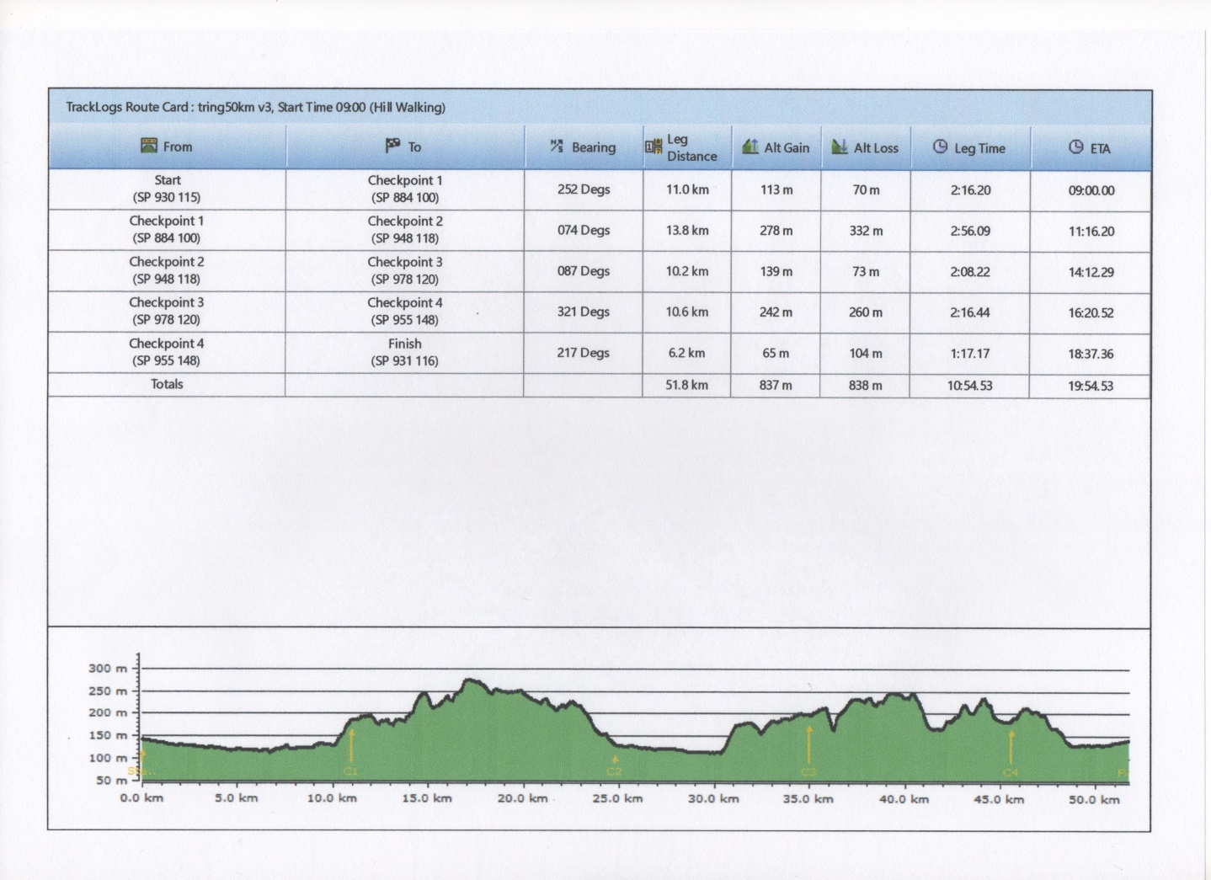

Spectator Information

If you have spectators who would like to follow you around the course we suggest the following locations to go and watch. The checkpoints are in quite small car parks or on the side of the road so we cannot have to many vehicles on site.
The first venue that we would recommend is the Café in the Woods, in Wendover Woods. The competitors run within 100m of the café at about 9 miles. There is plenty of parking. The postcode is HP22 5NF.
The second location is the monument in Ashridge Forest Estate. There is a café and lots of parking. Postcode HP4 1LT.

Safety on the Course

The following information is important. Please read it carefully. This information will also be covered in the compulsory briefing prior to the event.

Route Hazards

- The ground maybe slippery so please be careful.
- Be aware and take caution crossing all roads – some are busy. Wait till it is safe to cross. Only one crossing is marshalled
- Be aware of other path users especially where it is narrow, dogs off the lead, horses, mountain bikes, walkers are all potential hazards.
- Caution with roots, rocks, steps, stiles that may be hidden or slippery
- All gates MUST be closed after you.
- Take EXTRA care when moving along the canal side, proceed in single file, where necessary and take care of others users. If you fall in the canal, it’s not deep, so you won’t drown but you will stink and if you swallow the water you are likely to get ill, so please let the medic know.

Medical

- Our paramedics will be on hand all weekend to assist with serious or minor injuries.
- Any incidents will be dealt with as part of our medical emergency procedures.
- It is important that you check the medical page of the website to ensure you have understood the potential medical risks of running these extreme distances.
- It is also important that you let the organisers know in advance of any medical problems that you know about and may be relevant to the race.

Actions On

Injury
- Try to get to a Checkpoint, where we will be able to recover you or treat you.
- Get to a recognisable location where you can report your position and ring Neil, Ian or Rich, (numbers on the map),
- Tell another competitor where you are and ask them to inform the next CP, we will then plan your recovery

Our paramedic team will be on the course and at the finish and will manage all situations that need treatment. XNRG Medic – 07599937708

Serious Emergency (i.e. someone is knocked down) ring 999 first, then ring the XNRG Medic – 07599937708

Medical Emergencies will be taken to A & E

Lost

- Keep eyes on signs.
- Use the map.
- Look for fellow competitors behind or in front.
- Retrace steps to last known location.
- Ask a local walker/runner for help.
- If still lost, try to get to a road or town, ask at a pub or shop to help locate on the map.
- Or find a road with a name, a town and ring Neil, Ian or Rich, (numbers on the map), to help guide you in.

Withdrawal

Only withdraw at a checkpoint and ensure the CP staff have been told you are withdrawing. We will get you to the finish when the CP closes.

Missing Checkpoint Time

- If you are too fast, or start in the wrong start and the CP is not set up, then you will need to decide whether you keep going or wait.
- If you are too late for a CP, we will keep it open till you arrive; if you are late for 2 CPs we may ask you to withdraw.

Dark

Head torches must be worn once it is dark, anyone arriving at a CP in the dark without a head torch will be pulled out.

